

Tablet Sorter and Dispenser

Project Engineering

Year 4

Oisin O’Rourke

Bachelor of Engineering (Honours) in Software and Electronic Engineering

Atlantic Technological University

2022/2023

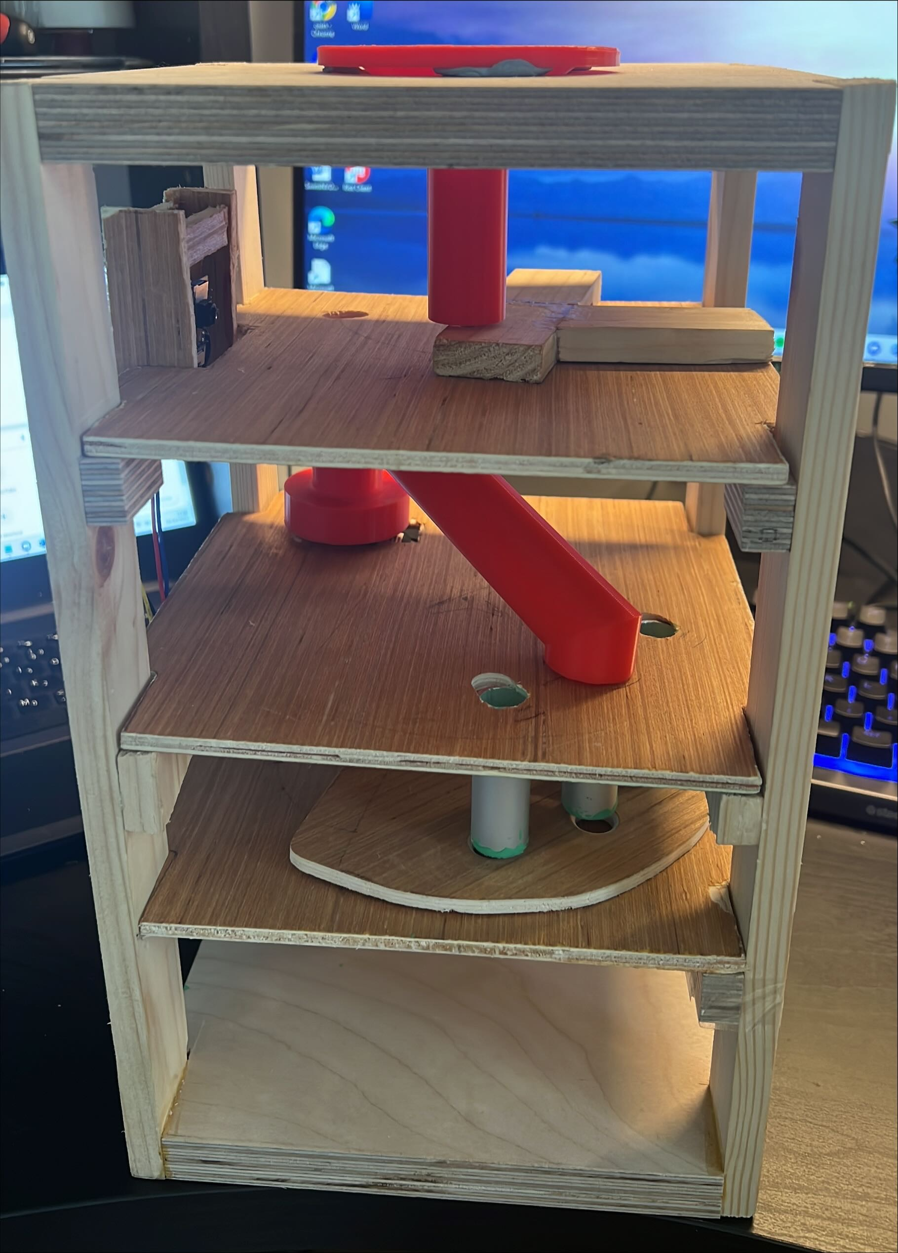

**Declaration**

This project is presented in partial fulfilment of the requirements for the degree of Bachelor of Engineering (Honours) in Software and Electronic Engineering at Atlantic Technical University .

This project is my own work, except where otherwise accredited. Where the work of others has been used or incorporated during this project, this is acknowledged and referenced.

**Acknowledgements**

I would like to thank all the lectures that have helped me throughout the last four years in the course that have helped me to hone my skills that allowed me to complete this Final Year Project. I would like to give a special thank you to my mentor Michelle who was there every week to check up on my progress and help me with any problems I had encountered.

I would like to thank my friend Daniel who allowed me to use drill bits big enough for the tablets to fit as I didn’t have them myself. This allowed me to create the dispenser pieces.

I would like to finally thank all my classmates that pushed me to get as good of a project as I was capable and for helping me at any point where they could.

**Table of Contents**

Summary 6

Poster 7

Introduction 8

Hardware 8

Image processing 15

Custom Vision 16

Script writing 18

Camera local host page 18

Docker 19

Postman 19

Tablets 20

Lighting 20

Project Architecture 21

Project Plan 22

Schematic diagram 23

Ethics 24

Conclusion 25

References 26

### Summary

For my final year project, I wanted to incorporate as many of the key areas I’ve enjoyed in my course over the past four years. I needed an idea that would allow me to demonstrate my software skills while also keeping a large amount of the project hardware based as that’s what enjoy the most.

The idea for the project came to me over the summer at my grandmothers. We were sorting out the weekly prescription into the tray that had a compartment for each day of the week. This job was made harder by mild arthritis and small writing on the bottles. I wanted a way to automate this tedious job that must be done weekly. The goal I set myself was to make a project that could sort the tablets and dispense them. This would take away this tedious task and would make it easier to take the prescription every week.

After looking into the subject, I discovered an article published by the Royal College of Surgeons in Ireland. They discovered that over the past twenty years the number of people being prescribed five or more medications increased 400%. This meant that there are more people in Ireland than ever before taking prescribed medication. This showed me there was a growing market for devices like these. On the market currently I have seen two very expensive models that offer the same functionality as my one. The goal was to get a functioning product for a much cheaper price.

This project idea incorporated may of the key learnings from this course on both the hardware and software side. The project has a camera and an FTDI module and an ESP32 and servo motors linked up to a laptop. These were accompanied by hardware made of wood and 3D printed pieces that were designed to hold and move the tablets to the correct area. Controlling the camera and motors there was a python script running on the laptop which linked up all the software in the project.

Overall, this was a fun and challenging project to undertake and was a good showing of all the skills I have learned in the past four years in the course.

### Poster

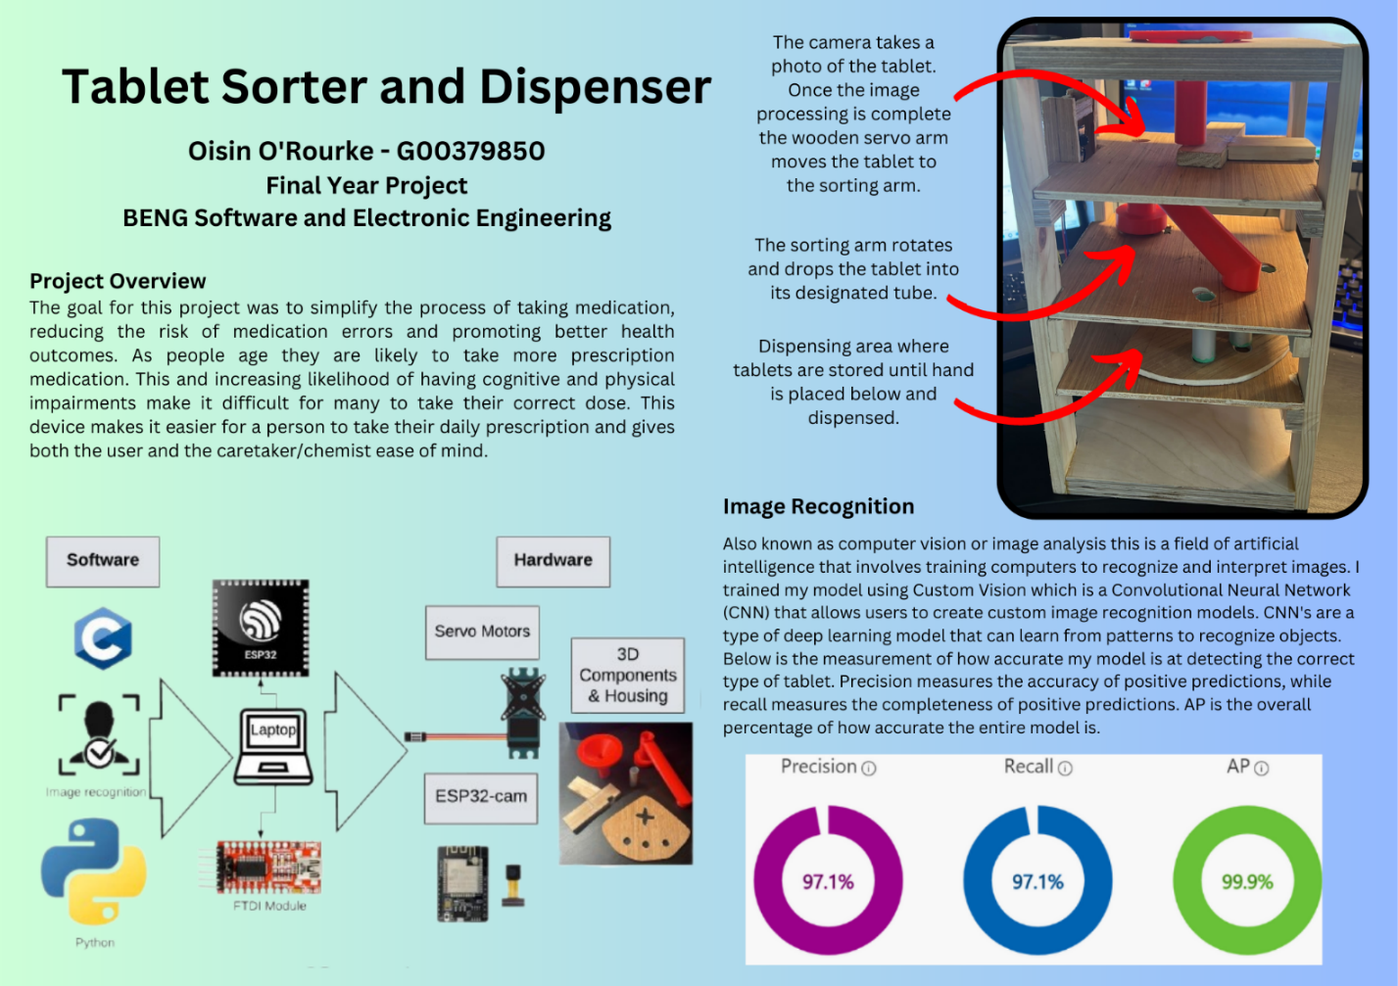

### Introduction

Welcome to the final year project report written by Oisin O’Rourke final year student in ATU. For this report I’m going to discuss all the key areas in my final year project. The goal of this project is to make a device that can sort tablets using a trained image recognition model. The trained image model was created using custom vision and exported as a docker file and tested locally using postman. The python script automates all the tasks in the project. This project incorporates skills learned over the past four years on both the hardware and the software side.

### Hardware

**BOARD**

The Esp32 board is a lightweight low-cost powerful microcontroller that was perfectly suited for this project. The microcontroller runs at 240MHz making it more powerful than many other microcontrollers while also being very energy efficient. This board is also compatible with the Arduino ide which is something familiar to me so a good starting point in the project. The esp32 also has a large and active community that use and share feedback about the module. This would be beneficial when trouble shooting with the board. The Esp32 is an overall versatile and compatible microcontroller that offers enough features and capabilities for an affordable price.

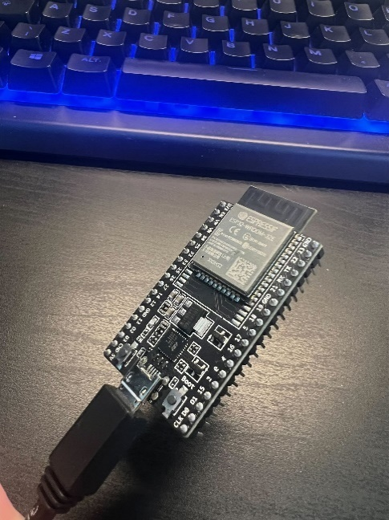

**Servo Motors**

This build contains three standard servo motors. Each of these motors has a different purpose. The first motor at the top sets the wooden arm to the correct position to allow a picture of the tablet to be taken. Once the image recognition is done it can then send the tablet to the sorting arm. Depending on what the camera saw the previous motor the second motor moves the sorting arm to direct the tablet to the correct tube. The final motor activates the dispenser. This allows the user to get one of each tablet my model is trained to detect.

Servo motors are a small 5V motor that has a shaft position that can be precisely controlled. The servo motor uses a servomechanism that provides positional feedback. Servos are set to their angle using Pulse Width Modulation for high accuracy.

The servo is coded in Arduino ide.

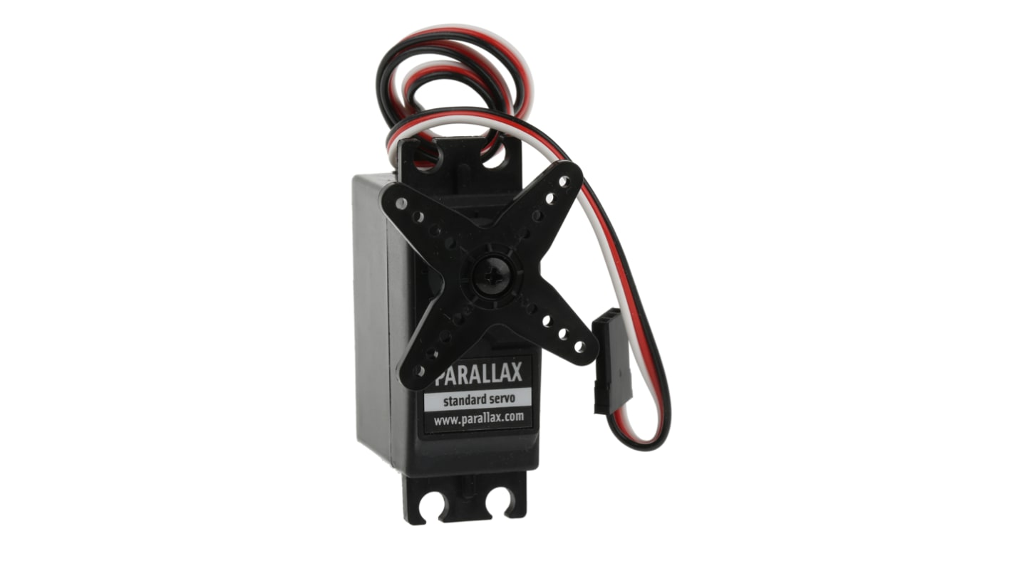

**Camera & FTDI module**

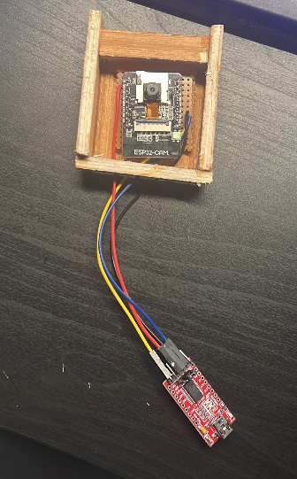The camera used for this build is the ESP-Cam this is a small light weight, cheap module that offers all the functionality needed in a project like this. Connected to the camera is an FTDI module. An FTDI module is a USB to serial adapter that can be used to communicate between a computer the camera. This makes it more straight forward to get the camera running as the FTDI module is specifically designed for serial communication. Using this module, it also helped reduce the complexity of the project by offloading the serial communication tasks to a separate module. This helped to simplify the code and separate it for less risk of errors and makes for more efficient debugging.

**Parts list:**

The hardware in this project is made of simple woodworking techniques, 3D drawings and other small waste materials that would otherwise be thrown out were repurposed for this build.

The list of all hardware components for this build include:

* 4x (340mm x 40mm x 10mm) thin pine planks.
* 2x (200mm x 200mm x 20mm) thick plywood for base and top.
* 3x (200mm x 200mm x 6mm) plywood separators.
* 3x (50mm x 14mm inside diameter x 18mm outside diameter) metal tubes.
* Wooden camera housing
* Wooden photo arm.
* Dispenser arm.
* 3D printed Funnel.
* 3D printed Sorting arm.

Electrical components:

* ESP32 microcontroller
* ESP-Cam
* FTDI Module
* 3x standard servo motors

**Frame:**

To start this build we have a frame made from pine wood and plywood. The pine made up the four standing structures and plywood was used for the base and the top. The base and the top have notches cut out the size of the pine to allow there to be a smooth joint at each corner. The cut offs would then be glued to the pine to hold up the dividers in the next section. This allows you to work on the device but also you can take it apart as the dividers will be removable which allows alteration throughout the build if necessary.

There was also a cut out made the size of the funnel to allow it to sit on the top. Note: do this step before screwing the frame together as cutting it after makes the piece much more difficult to work with.

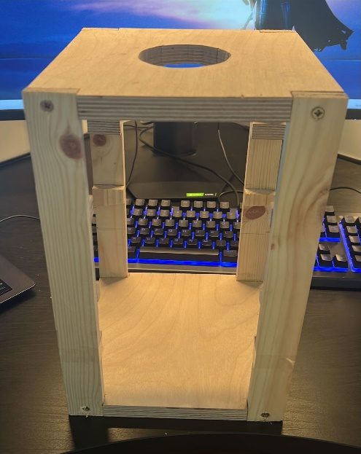

**Dividers:**

After the housing was finished, the inside was then divided it into four different sections.

The top section is where the camera would take a photo of the tablet and determine what it was. In this section you can see the camera on the left will take a photo of the tablet that will be sitting in the notch cut out of the moving wood piece connected to the servo motor at the top.

The second section is where the sorting arm will be located and from here the tablet would be sorted into its correct tube.

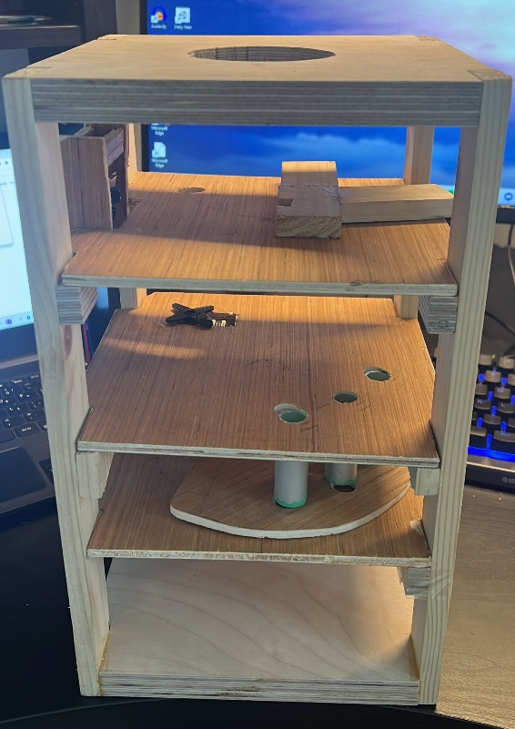The third section is where the sorted tablets will be held until they are dispensed. The small piece of wood below the tubes will allow one of each of the tablets through to the bottom section where a tray or a hand will be waiting to collect the tablets when they are dispensed.

**Servo Arms and Tubing:**

In the divider photo you can also see the addition of some other components. The first thing you can see is the wooden photo arm this is the piece on the right in this image. This piece waits at the bottom of the funnel and will show the camera one tablet. There is a cut out on the underside that fits the servo motor. There is a notch cut out with a piece of clear plastic making a window so the tablet can’t roll away while allowing the camera to take a photo. It also has a tail that stops other tablets leaving the funnel until the notch comes back to collect the next tablet in the funnel.

The next components are the three metal tubes in the third section these will store the tablets just like the funnel and the dispenser wooden piece will allow one tablet into each of its holes from each of the tubes and dispense them.

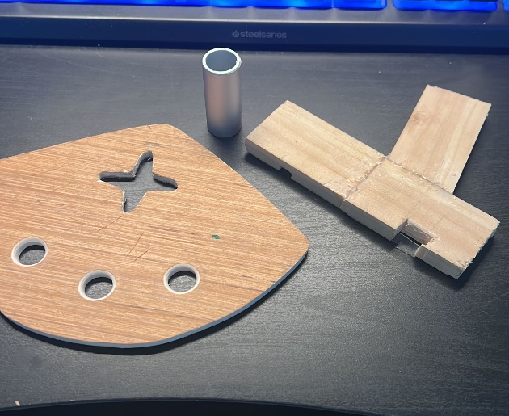

**3D Printed Components:**

Two components in this build were drawn using On Shape a free online 3D drawing tool. These drawings are linked on GitHub at the bottom of the report. The two components drawn using this software included the Funnel and the Sorting Arm. 3D printing these components was necessary due to the high accuracy needed for the size and shape of the tablets in the build. It would not be possible to build these components out of wood like the rest of the build. The On Shape software allowed me to export my 3D drawings as STL files. These are the files needed by 3D printers to create the parts. In this project these files were then imported into IdeaMaker which is the software used by the 3D printers in ATU. In idea maker you can add supports and make any changes the printer may need to print your specific components. As these components aren’t too complicated, I was ok to stick to the basic settings and no supports were needed the default settings in the idea maker software worked just fine. Below is the two parts and how they were added into the housing. Note that the sorting arm has a base printed so the servo motor could sit into it allowing the arm to move when the servo did.

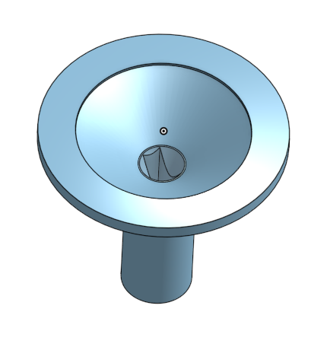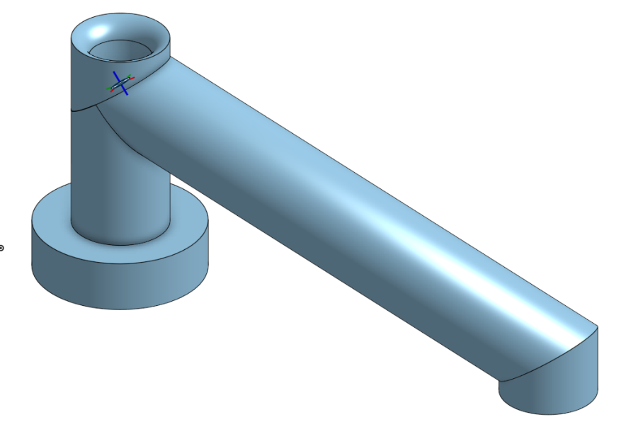

### Image processing

Image recognition is a very important element in this project. Image recognition is the process of identifying objects, people, or patters within an image. We will need to implement this into our project so when the camera takes a photo of a tablet, we can identify what type of tablet is in the image. Image recognition is a computer vision technique that involves training a machine learning model to identify objects or patterns within an image.

The basic approach to image recognition involves three steps:

Pre-processing: The first step is to pre-process the image. This is done by resizing, cropping, and normalizing the image. Normalization is a process that changes the range of pixel intensity in an image. This step ensures that the image is consistent across different training examples.

Feature Extraction: This next step involves extracting features from the pre-processed image. Features are unique characteristics that would differentiate one image from another. There are several techniques used for feature extraction these include Texture features, Edge-based features, shape-based features, colour-based features, deep learning features and more. Depending on the images in your model you may use some of these techniques more than others. In our case with tablets, we would mainly use colour, Edge-based features the most and because tablets often look the same, we would use Deep learning-based features.

Classification: The final step is to classify the image by assigning it to a specific category. This step involves training a machine learning model on a dataset of labelled images to learn the patterns and features that differentiate one category from another.

After understanding how image recognition works the next step is to create an image recognition system.

Creating an image recognition system involves:

Model Training: This step builds on the three previous steps. Here you add all your control images that you are going to train your model using. To train the model you must give every photo in the model a tag, so the machine knows what is in the image and groups all the images with the same tags together. Using the three previous steps the system then knows differences between the tags and therefore knows what’s in the image.

Model Evaluation: Once the model is trained, it needs to be evaluated on a separate dataset of images that were not used in the trained model. This step ensures that the model is working and can recognize new images accurately.

Deployment: Once the model is trained and evaluated, it can be deployed and used. This step involves integrating the model into an application that can recognize images in real-time.

### Custom Vision

Custom vision is a cloud-based image recognition service provided by Microsoft Azure. It allows developers to create custom vision image recognition models. The service allows you to add your own images and tag them into their specific categories. The system then trains the model based on the images and tags provided. I choose to use custom vision in this project as it allowed me faster development times and more flexibility compared to building a custom image recognition model from scratch.

Once the trained model was complete, you can then export the code as a Docker file. This docker file would run locally on the laptop. This would allow you to run this file on Postman to test the images locally. Postman is a popular API development tool that allows developers to test and debug APIs. It has a user-friendly user face which makes it a perfect choice to implement into this project. You would have to give postman an image from the camera, and it would give a response indicating the probability of what tablet is in the image. This would be done using a python script that would interact with postman automatically.

In the below image you can see how accurate the trained model is. I have more photos taken of the mix tablet as there are two different sides and more learning is required for it. This model is very accurate but can be improved with the same image count across the different tags.

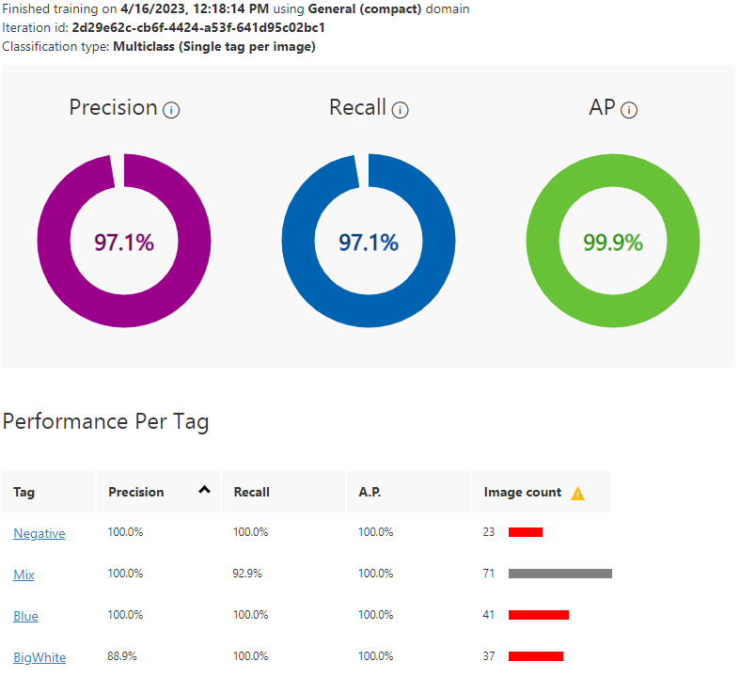

### Script writing

To combine all parts of the project together you must write a python script. This allows the tablet sorter to automatically work without any input from the user. This would also allow all the components of the project to interact with each other locally through the laptop. As this device does the same thing over and over with just a little variation on where the servos go each time automating this makes it a much more user-friendly device. Python scripts can be easily modified and reused for different tasks.

To get started with scripting there are links at the bottom of the report that include a three-hour tutorial on the basics of python scripting. There is also a link to a video on interacting with webpages and how to click buttons. This is vital for the camera web application so you can set the camera settings, take a photo, and save the image.

### Camera local host page

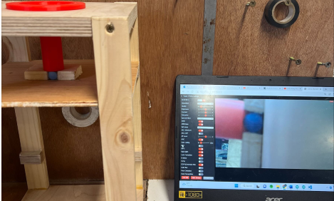To take the images from the camera the project used a sample code from Arduino ide called esp32cam-WifiCam this sample code allows the user to take and save images. This also had added functionality that can change the resolution, quality, brightness, contrast, saturation and much more settings when taking the image. This allows the user to have more consistent images for the trained model and helps with colour saturation if there are similarities between different tablets.

### Docker

Docker is a containerization platform that allows developers to package their code and dependencies into a single portable container. Docker provides a consistent runtime environment for the application regardless of the host operating system. This makes it easy to develop, test and deploy applications and to ensure consistency across different environments. Using custom vision, you have multiple options when exporting your trained model. This allows you to export the model and use it in applications outside the custom vision webpage. Along with the exported code from custom vision there is a txt file outlining how to build and run the docker file.

### Postman

When testing the exported code from Custom Vision, Postman can be used to send a test request to the API while the Docker file is running. To create a request, the HTTP method and the URL of the API endpoint must be specified. On the request body page in Postman, an image can be uploaded for testing. Upon pressing "send", the response will contain the results of the image recognition, which can be used to identify the object in the image. This process allows for efficient testing of the image recognition functionality of the API.

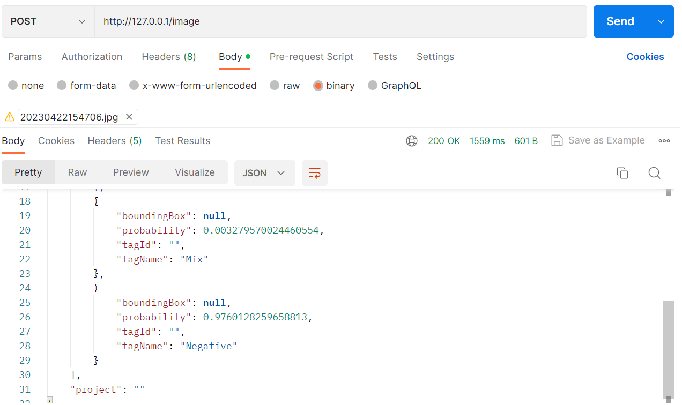

### Tablets

When testing this project, we need three different tablets. These tablets are photographed below. These were out of date tablets that were in the bin about to be thrown out from a local chemist. As you aren’t allowed any tablet you like without a prescription, I just got two of each tablet, but this was plenty to prove the model works and was ok to run and test it.

### Lighting

As this is the first iteration of this device there are always going to be issue. After testing of the device, it became apparent how important lighting is when using image recognition. Especially when dealing with tablets that can look very similar to a low-quality camera module. If the model is trained in a bright place but the device is left in a dark area or if it tries to sort the tablets at night, it runs into problems it wouldn’t have otherwise. Shadows and difference using inside light sources have a bigger impact than anticipated on the image recognition. If this device was to be done again or improved, it would be a good idea to either train the model with a wider selection of images in all types of lighting or have the whole device closed and implement a light source inside the device for consistent lighting anywhere the device is stored.

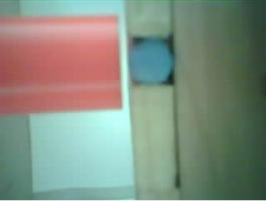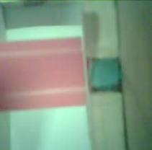

Low Lighting

Good Lighting

### Project Architecture

In the architecture diagram you can see all the components involved in the making of this project. On the left-hand side, you can see the use of the C programming language this was used to control the servo motors. This code was written using the Arduino ide and it runs using the ESP32 microcontroller. Below this you can see Image recognition this represents the Custom Vision trained model which carries out the image recognition that allows the device to tell which tablet is in the image. The last component in the software side of the project is the python script. This allows you to automate all the tasks, so the machine runs through all the process itself automatically without the need of an operator on the device.

This project runs on a laptop. Connected to the laptop is the FTDI module and an ESP32 microcontroller. The FTDI module is used to run the ESP32-cam and the ESP32 is used to control the servo motors. There are multiple custom 3D components and the housing connected to the servos and cameras to allow the device to sort the tablets. More information on these components can be found in the hardware section.

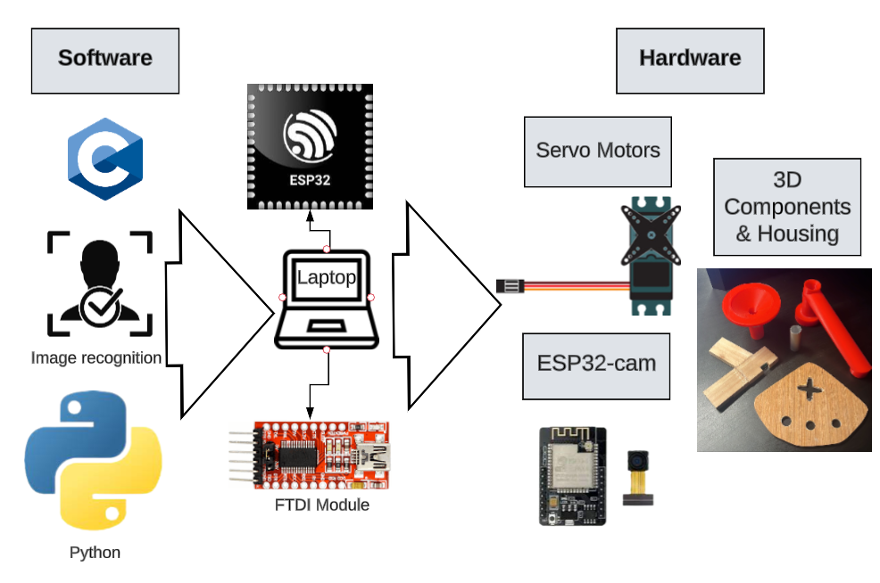

### Project Plan

To plan out my project and ensure I made deadlines and consistent progress I used Jira. Jira is a project management tool developed by Atlassian. It is designed to help teams track, organize, and manage their workloads as efficiently and effectively as possible. Jira is a very popular tool for software development teams so this is a perfect tool for people to use in their final year projects to get familiar with the software before going into industry.

Jira allows you to create and track all the active tasks you’re working on. It also allows you to highlight bugs so your team can see where your issues are. One of the main benefits to Jira is its flexibility and customization. Users can create their own workflows and burndown charts to allow the user to track their progress.

Overall Jira is a good tool for managing work efficiently and to ensure no tasks are forgotten. Below is a screenshot of my timeline that highlights many of the different tasks involved in the making of this tablet sorter and dispenser.

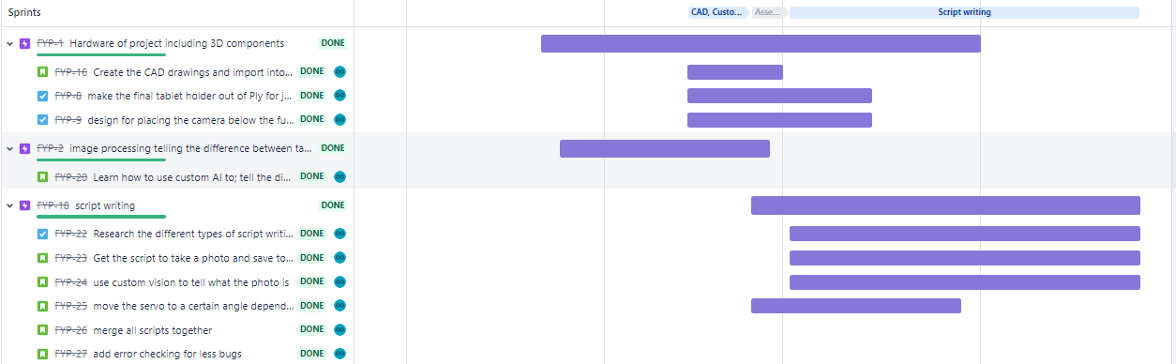

### Schematic diagram

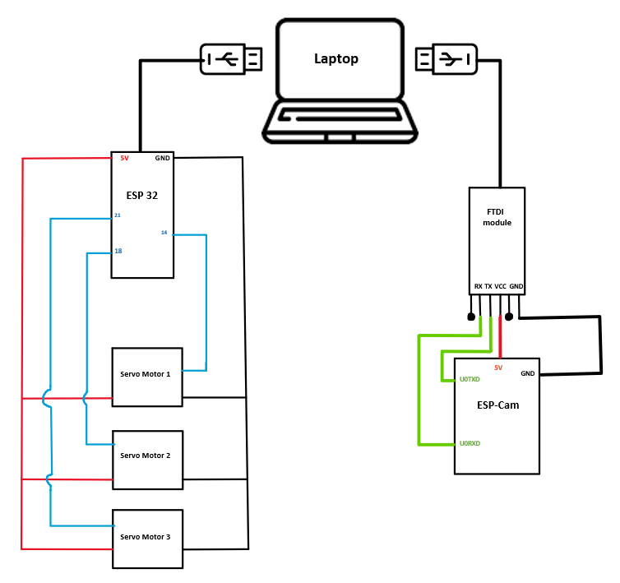

In the schematic diagram you can see on the left the wiring of the servo motors and the pins used to operate each servo motor. On the right you can see what pins are connected when wiring the FTDI module to the ESP-Cam. Both the FTDI module and the ESP32 then connect to the laptop.

### Ethics

Ethical considerations are an important part of any project involving image recognition and moving motors. In this section I will discuss the main ethical issues that were taken into consideration when developing this device.

Privacy is a big concern for this project. The camera must be made in a way to not take images of people using the device. To fix this I have a white sheet that doesn’t allow the camera to take any image of the background. This also had the added benefit of making the learning model better as the image wasn’t taking the background into consideration and the lighting in the device was more consistent.

Safety was an important consideration, particularly if the device identified the tablet wrong. This would result in the user getting an incorrect dose. To ensure that the system was accurate and reliable there were rigorous testing and validation carried out to make the model as reliable as possible.

Safety is also important in relation to the hardware. There are moving parts and electricity needed for this project. In a project with moving parts, it was important to design it in a way that no user could injure themselves while operating the device.

Consent would have to be a key consideration if this project would be made public. You would need access to the patient’s prescription and keep up with any changes that are made to it over time. Luckily for this build we didn’t have any actual prescriptions.

### Conclusion

In conclusion, this tablet sorter and dispenser project was a great success, demonstrating both technical skills and personal initiative. The hardware and software aspects of the project were well integrated, with the electronic side using the servo motors and the camera to the ESP32 and the FTDI module. The woodworking and 3D drawing and printing of components shows skills learned outside the course. The software skills were also highly tested in the making of the project, including image processing, servo motor, camera coding and the use of python scripts to merge all the code together. The initiative to research and learn a new coding language was impressive and shows the drive and motivation I had in the making of the project. With further improvements such as a user interface and safety features, this project could have significant practical applications in the healthcare industry. Overall, the tablet sorter and dispenser project is a testament to the hard work and skills learned over the past four years.

### References

[1] “Sorting Machine- Skittles and M&M’s” [Online]. Available:

https://www.youtube.com/watch?v=H7HTQai7Wwg&ab_channel=ivcvideo

[2] “Esp32 data sheet.” [Online]. Available:

<https://www.espressif.com/sites/default/files/documentation/esp32_datasheet_en.pdf>

[3] “Introduction to python scripts.” [Online]. Available: <https://www.youtube.com/watch?v=s8XjEuplx_U&ab_channel=freeCodeCamp.org>

[4] “Page navigation and clicking elements python tutorial” [Online]. Available:

<https://www.youtube.com/watch?v=U6gbGk5WPws&ab_channel=TechWithTim>

[5] “ESP 32 cam setup” [Online]. Available:

https://www.youtube.com/watch?v=lVRYdDcngCg&ab_channel=CodingScientist

[6] “Basics of image processing” [Online]. Available:

<https://www.youtube.com/watch?v=N8wwIEfSn0M&ab_channel=GoeduhubTechnologies>

[7] “Servo motor workshop” [Online]. Available:

<https://www.youtube.com/watch?v=zxBC1ivOVfM&t=796s&ab_channel=DroneBotWorkshop>

[8] “3D printing and slicing using idea maker” [Online]. Available:

<https://www.youtube.com/watch?v=cgWGHSJotAk&ab_channel=Raise3DTechnologies>

[9] “Exporting trained model and testing” [Online]. Available:

<https://www.youtube.com/watch?v=F5XfpTkNER8&ab_channel=MicrosoftDeveloper>

[10] “introduction to Python scripting” [Online]. Available:

<https://www.youtube.com/watch?v=s8XjEuplx_U&ab_channel=freeCodeCamp.org>

[11] “clicking buttons on a webpage using python” [Online]. Available

<https://www.youtube.com/watch?v=U6gbGk5WPws&ab_channel=TechWithTim>

[12] “Stack Overflow for bug fixes” [Online]. Available:

<https://stackoverflow.com/>

[13] “Link to the projects code” [Online]. Available:

https://github.com/oisinor01/FYP-Tablet-Sorter-and-Dispenser-.git